**Conv1d + LSTM Model for Text Sentiment Analysis**

**About:**

These models are a combination of Convolutional Neural Network [CNN] and Recurrent Neural Network [RNN] where we use both the layers Conv1D and LSTM (Long Short-Term Memory) alternatively. This model classifies the text data into two classes namely:  'positive' and ‘negative’.

The dataset contains about 200 thousand records which are shuffled rigorously and split into train and test data in the ratio of 90:10.

**Model 1:**

**The model summary is as follows:**

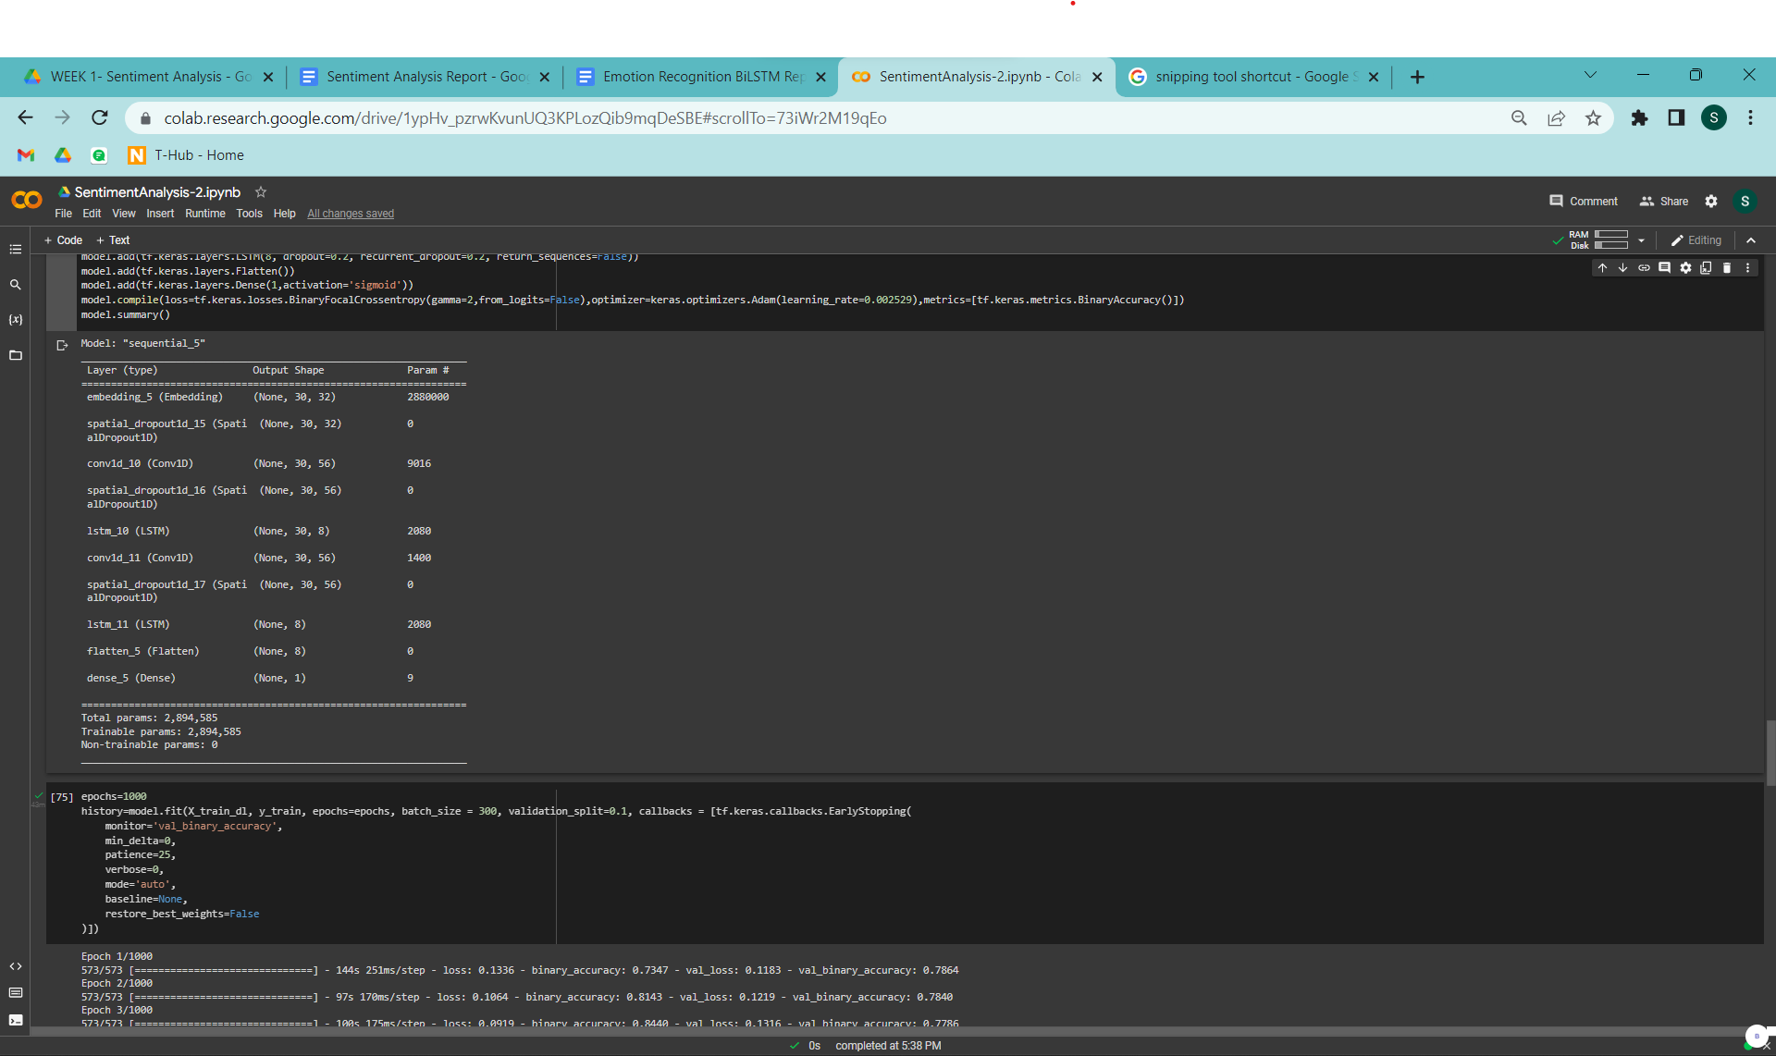

Model ran for 26 epochs with a batch size of 300.

**Classification report:**

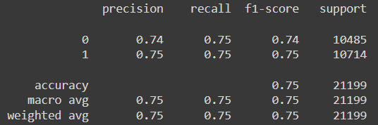

**This is the normalized confusion matrix for the predictions:**

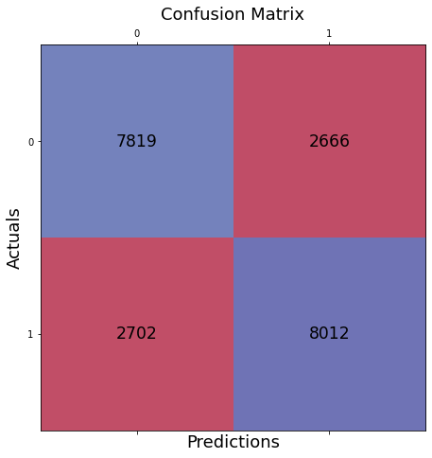

**Training Curve:**

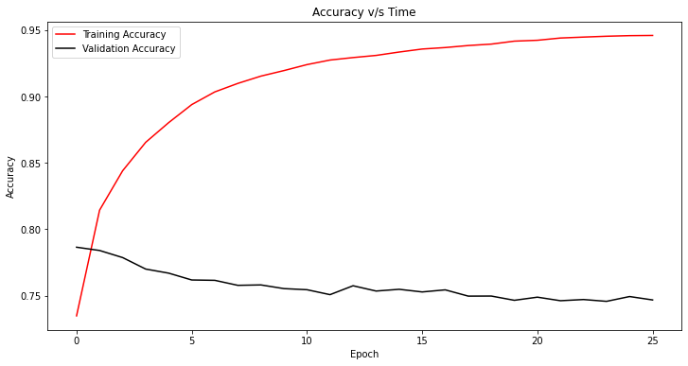

**Model 2:**

**The model summary is as follows:**

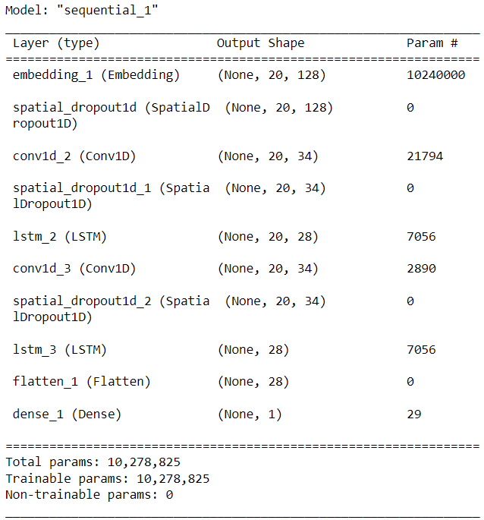

Model ran for 11 epochs with a batch size of 500.

**Classification report:**

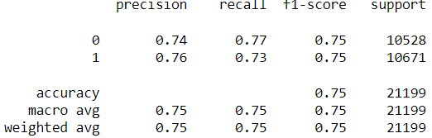

**This is the normalized confusion matrix for the predictions:**

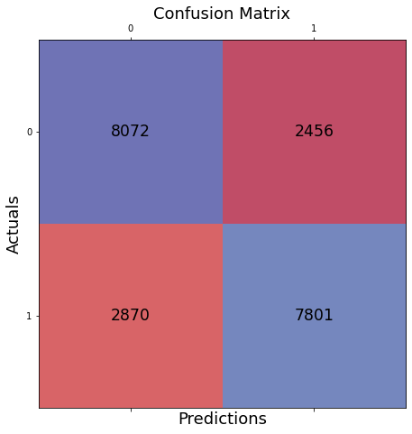

**Training Curve:**

